HTML CSS Interview
- What is HTML?
It tells the browser how to display text, images, and other elements on a webpage.
- HTML is a markup language, not a programming language.
- It defines the structure of a webpage using tags and elements.
- HTML is static

- What are HTML tags?
HTML tags are special keywords enclosed in angle brackets (< >) that tell a web browser how to display content on a webpage.

- What’s the difference between HTML and HTML5?
HTML is the general name for HyperText Markup Language, and HTML5 is the latest launched version in 2014.
Aspect | HTML | HTML5
Doctype | Long & complex | Simple: <!DOCTYPE html>
Multimedia | Needs plugins (Flash) | <audio>, <video>
Graphics | No native support | <canvas>, <svg>
Forms | Basic inputs | New inputs: email, date, etc.
Semantic Tags | Uses <div> mostly | <header>, <footer>, <article>
APIs | None | Geolocation, Web Storage, etc
- What is the difference between <section>, <article>, and <div>?
🧩 1. <section>
Used to define a thematic grouping of content — usually with a heading (<h1>–<h6>).
Purpose:
Represents a section of a document, like chapters, introduction, or contact info.
📰 2. <article>
Used for self-contained content that can stand on its own or be shared independently.
Purpose:
Represents independent, reusable content like blog posts, news articles, or forum posts.
📦 3. <div>
A generic container with no semantic meaning — used for grouping elements purely for styling (CSS) .
Purpose:
Used when no other semantic tag is suitable.

- What’s the basic structure of an HTML document?
It’s like the blueprint for your web page. Here’s what goes in it:
- <!DOCTYPE html>: Tells the browser this is an HTML5 page.
- <html>: The main container for everything else.
- <head>: Holds behind-the-scenes info like the page title or links to CSS
- <body>: Where all the visible stuff goes, like text, images, or links.

- What’s the difference between a tag and an element?
A tag is just the code you write inside angle brackets.
An element is the opening tag, the content inside, and the closing tag.
Tags are the tools, and elements are what you build with them.
- Tag: <div> or </div>, just the code.
- Element: <div>Hi there!</div>, the tag plus content.

- What are attributes in HTML?
Attributes are extra details you add to an opening tag to give it more powers. They look like name="value".

- How do you create hyperlinks? What are absolute vs relative URLs?
A hyperlink is created using the <a> (anchor) tag and an href attribute that says where the link goes. The text inside the tag is what people click on to visit another page or resource.

Absolute URL: An absolute URL specifies the full path to the resource, including the protocol (http, https, etc.), domain. It works independently of the current page location.
Relative URL: A relative URL specifies the path to the resource relative to the current page’s location. It is used when linking to resources within the same website/project.

- What’s the difference between block-level and inline elements?
- Block-level elements: Take up the whole width of their space, start on a new line, and stack like boxes (e.g., <div>, <p>, <h1>). They’re great for big sections like paragraphs or headers.
- Inline elements: Only use the space their content needs, stay on the same line, and flow with text (e.g., <span>, <a>, <img>). They’re perfect for small bits like links or images within a sentence.

- What kinds of lists can you make in HTML?
- Ordered List (<ol>): Shows items with numbers or letters (like 1, 2, 3).
- Unordered List (<ul>): Uses bullets for items.
- Description List (<dl>): Pairs terms (<dt>) with their descriptions (<dd>).
<dl>
<dt>**HTML**</dt>
<dd>**HyperText Markup Language**</dd>
</dl>
Display like this
**HTML**
**HyperText Markup Language**

- What is the <form> tag and what do action and method do?
<form> is an HTML element used to collect user input and send it to a server/backend for processing — like login, signup, search, contact form, payment, etc.
action specifies where (URL / API endpoint) the form data will be sent after submission.
method defines how the data will be sent to the server (HTTP request type).
Most common:

1. GET
- Sends data in URL (query string)
- Visible in browser
- Good for search forms
- Less secure
<form action="/search" method="GET">

2. POST
- Sends data in request body
- Not shown in URL
- Used for login, signup, sensitive data
<form action="/register" method="POST">
NOTE:
✅ GET — two practical uses
- Retrieve data (main/intended purpose) ✅
- Send small non-sensitive data via query params ✅

- What does the <br> tag do and when should you avoid it?
<br> creates a line break, but should not be used for spacing or layout — use semantic tags and CSS instead.

- How do you make a link open in a new tab safely?
Use target="_blank" with rel="noopener noreferrer" to open links safely in a new tab and prevent security risks like tabnabbing.
What each does
- target="_blank" → opens link in a new tab
- rel="noopener" → prevents the new page from accessing window.opener
- rel="noreferrer" → hides referrer URL & provides extra safety

❌ Why is target="_blank" alone unsafe?
Without rel="noopener" the new tab can:
- window.opener is a JavaScript property that gives the newly opened tab/window a reference to the page that opened it.
- redirect your site (phishing attack)
- steal data
This is called tabnabbing attack.

- What does the <title> tag do and why is it important for SEO?
The <title> tag sets the name of your web page that appears in the browser tab and helps people and search engines know what your page is about.
- Helps Search Engines: Makes it easier for Google and others to understand your page.
- Helps Visitors: Lets people quickly see what your page is about, so they know if they want to click.

- What’s the <meta>tag?
The <meta> tag lives in the <head> and gives extra info about your web page, like what character set it uses, a description for search engines, or settings for mobile screens.
It’s not visible to users but helps browsers and Google understand your page better.
<meta charset="UTF-8"> <!-- Sets the character encoding -->
<meta name="description" content="A cool webpage"> <!--Help with SEO -->
<meta name="viewport" content="width=device-width, initial-scale=1.0"> <!-- Makes it **mobile-friendly** -->

- How do you make an email link?
<a href="mailto:hello@example.com">Send an **Email**</a>

- What’s the <em> tag?
The <em> tag emphasizes text, usually making it italic. Unlike <i>, which is just for style, <em> has meaning—it tells screen readers to stress the text.
<p>I <em>**love**</em> to **code**!</p>
- How do you make a checkbox?
A checkbox uses <input type="checkbox"> to let users select multiple options. Use a unique id for each checkbox and connect it to a <label> for accessibility. Use the same name to group them and checked to pre-select.

<input type="checkbox" id="html" name="skills" value="HTML" checked>
<label for="html">HTML</label><br>

<input type="checkbox" id="css" name="skills" value="CSS">
<label for="css">CSS</label><br>

- What is the <label> tag and how does for/id improve accessibility?
The <label> tag provides a text description for a form input.
How for and id work together
You link a label to its input like this:
<label for="email">Email Address</label>
<input type="email" id="email">
Here:
- The <label> has for="email"
- The <input> has id="email"
Both match → Linked!
clicking the label focuses the input.
which improves accessibility by allowing screen readers to announce the correct label, and improves usability by letting users click the label to focus or activate the input.
- How do you make a dropdown list?
A dropdown list uses the <select> tag, with <option> tags inside it.
The name attribute sends the chosen value as a key, and value sets what goes to the server as value. Pair it with a <label> for accessibility.
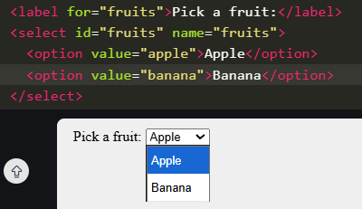
Fruits :“Apple”
- What is the <blockquote> tag and when should you use cite?
<blockquote> is used to display a long quotation (big quote) that are separate from the main text taken from another source.
You use the cite attribute inside <blockquote> to tell where the quote came from (the source URL).

<blockquote cite="https://example.com/article">
Learning never exhausts the mind.
</blockquote>
<q> → Short inline quote
- Used for small quotes inside a sentence
<p>Gandhi said, <q>Be the change</q>.</p>
- What are semantic HTML elements?
Semantic HTML elements clearly describe their purpose (e.g., <header>, <nav>, <article>, <footer>), making code readable, improving accessibility, and helping SEO.
- Improves accessibility for screen readers.
- Helps search engines understand page structure.

- How do you add a video in HTML5?
Using the <video> tag.
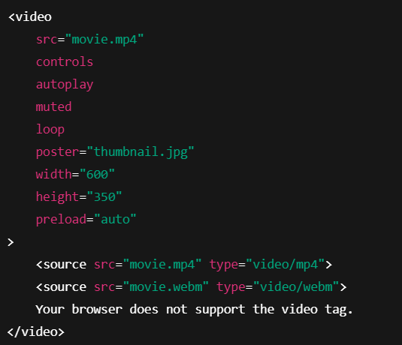
1. src: Direct source of the video file.
2. controls: Shows play / pause / volume / fullscreen buttons.
3. autoplay: Video starts playing automatically.
4. muted: Starts video without sound.
5. loop: Restarts the video after it ends.
6. poster: Image shown before the video starts.
7. width / height: Control the size of the video.
8. preload: Tells browser how much video to load before playing:
- none → Do not preload
- metadata → Load only info (size, duration)
- auto → Load whole video (browser decides)
9. <source>: Used to provide multiple video formats for better browser support.
10. Fallback Text: Shown when the browser doesn’t support video.

- What’s the <fieldset>tag?
<fieldset> groups related form elements together and draws a box around them.
<legend> provides a caption for that group.
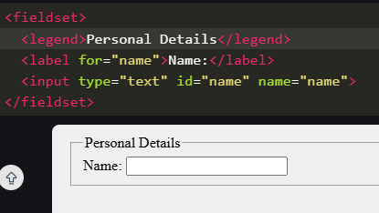

- What does <noscript> do and why is it still relevant?
<noscript> is an HTML tag that shows fallback content when:
- JavaScript is turned OFF in the user’s browser
- JavaScript fails to load (blocked, error, or unsupported)
Example:
<noscript>
JavaScript is disabled. Please enable it to use this site.
</noscript>
If JavaScript is ON → user will not see this.
If JavaScript is OFF → this message appears.
<noscript> still relevant
- Some users disable JavaScript for privacy/security.
- Scripts can fail to load due to network or CDN issues.
- Adblockers may block JavaScript files.
- When should you use <strong>/<em> vs <b>/<i>? (semantics vs presentation)
These tags add importance or emphasis that screen readers understand.
<strong>
- Means: “This is important.”
- Screen readers read it with strong emphasis.
<em>
- Means: “Emphasize this word.”
- Screen readers change tone (like stressing the word).

